# CHAPTER 1

# INTRODUCTION

In this Chapter, a brief introduction on Hospital Management System, Machine Learning and Image Processing has been given. Also, the description on types of Image Processing and Working on ML-Based image Processing has been focused.

## 1.1 Introduction to Hospital Management System

Hospital is the essential part of our lives, providing best medical facilities to people suffering from various ailments, which may be due to change in climatic conditions, increased work-load, emotional trauma stress etc. It is necessary for the hospitals to keep track of its day-to-day activities & records of its patients, doctors, nurses, ward boys and other staff personals that keep the hospital running smoothly & successfully.

But keeping track of all the activities and their records on paper is very cumbersome and error-prone. It also is a very inefficient and time-consuming process Observing the continuous increase in population and number of people visiting the hospital. Recording and maintaining all these records is highly unreliable, inefficient, and error-prone. It is also not economically & technically feasible to maintain these records on paper.

Thus, keeping the working of the manual system as the basis of our project. We have developed an automated version of the manual system, named "Hospital Management System".

The main aim of our project is to provide a paper-less hospital up to 90%. It also aims at providing low-cost reliable automation of the existing systems. The system also provides excellent security of data at every level of user-system interaction and provides robust & reliable storage and backup facilities.

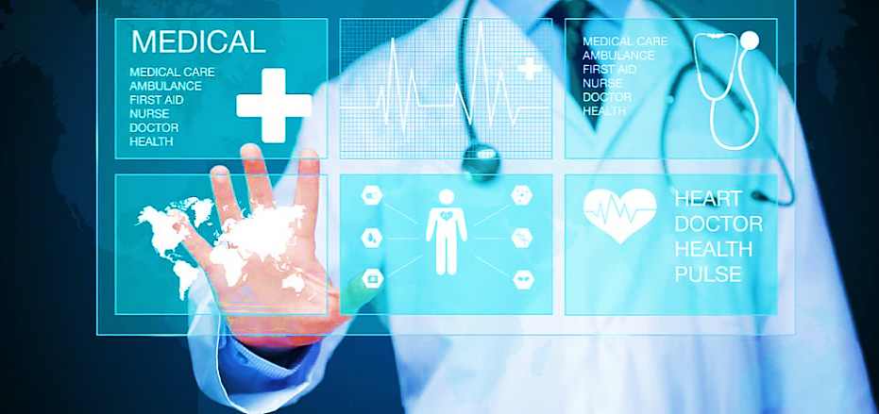

Fig. 1.1 Hospital Management System

**Problems faced in hospital management system:** Lack of Immediate Retrievals: The information is very difficult to retrieve and to find information like: to find patients history, the user has to go through various registers. This results in incontinence and wastage of time and resources. Lack of immediate information storage: The information generated will be completely computerised so no immediate issues. Lack of prompt updating: Various changes to information like patients’ detail or immunization details of child are difficult to make as paper work is involved. Error prone manual calculation: Manual calculation is error prone and take a lot of time this may result in incorrect information. For example, calculation of patient’s bill based on various treatments.

## 1.2 Introduction to Face Recognition

Facial Recognition is a recognition technique used to detect faces of individuals whose images are saved in the data set.

Recently face recognition is attracting much attention in the society of network multimedia information access. Areas such as network security, content indexing and retrieval, and video compression benefit from face recognition technology because "people" are the centre of attention in a lot of videos. Network access control via face recognition not only makes hackers virtually impossible to steal one's "password", but also increases user-friendliness in human-computer interaction. Indexing and/or retrieving video data based on the appearances of persons will be useful for users such as news reporters, political scientists, and moviegoers.

Step 1: Face detection: The camera detects and locates the image of a face, either alone or in a crowd. The image may show the person looking straight ahead or in profile.

Step 2: Face analysis: Next, an image of the face is captured and analyzed. Most facial recognition technology relies on 2D rather than 3D images because it can more conveniently match a 2D image with public photos or those in a database. The software reads the geometry of your face. Key factors include the distance between your eyes, the depth of your eye sockets, the distance from forehead to chin, the shape of your cheekbones, and the contour of the lips, ears, and chin. The aim is to identify the facial landmarks that are key to distinguishing your face.

Step 3: Converting the image to data: The face capture process transforms analog information (a face) into a set of digital information (data) based on the person's facial features. Your face's analysis is essentially turned into a mathematical formula. The numerical code is called a faceprint. In the same way that thumbprints are unique, each person has their own faceprint.

Step 4: Finding a match: Your faceprint is then compared against a database of other known faces. For example, the FBI has access to up to 650 million photos, drawn from various state databases. On Facebook, any photo tagged with a person’s name becomes a part of Facebook's database, which may also be used for facial recognition. If your faceprint matches an image in a facial recognition database, then a determination is made.[1]

**Importance of Facial Recognition Solution in Modern Times**

In the current scenario, when identity theft is widespread, face recognition technology can play a significant role in preventing identity fraud. According to a report of 2019, 3.2 million fraud cases were reported to the [FTC](https://en.wikipedia.org/wiki/Federal_Trade_Commission) (Federal Trade Commission), out of which, [20.33%](https://www.ftc.gov/system/files/documents/reports/consumer-sentinel-network-data-book-2019/consumer_sentinel_network_data_book_2019.pdf) of cases were identity-related.

Modern [AI](https://en.wikipedia.org/wiki/Artificial_intelligence)-enabled facial recognition technology offers a high level of accuracy and can match even the unique characteristics of a human face. Businesses and organizations of different types can leverage this technology to minimize the risk of identity theft to a great extent.

For hassle free working of hospital, we'll be designing a machine learning model deployed to a website that will be using face recognition technology to identify the patients and once detected the software will show entire medical history of that patient with an option of updating the medical record and more.

## **1.3 Machine Learning (ML)** has become one of most widely used AI techniques for several companies, institutions and individuals who are in the business of automation. This is because of considerable improvements in the access to data and increases in computational power, which allow practitioners to achieve meaningful results across several areas.

Machine learning is a field of computer science that gives computers the ability to learn without being explicitly programmed.

Machine learning is an application of artificial intelligence (AI) that provides systems the ability to automatically learn and improve from experience without being explicitly programmed. Machine learning focuses on the development of computer programs that can access data and use it learn for themselves.[4]

The process of learning begins with observations or data, such as examples, direct experience, or instruction, in order to look for patterns in data and make better decisions in the future based on the examples that we provide. The primary aim is to allow the computers learn automatically without human intervention or assistance and adjust actions accordingly.

Machine learning tasks are typically classified into two broad categories, depending on whether there is a learning "signal" or "feedback" available to a learning system, namely supervised, unsupervised and reinforcement system.

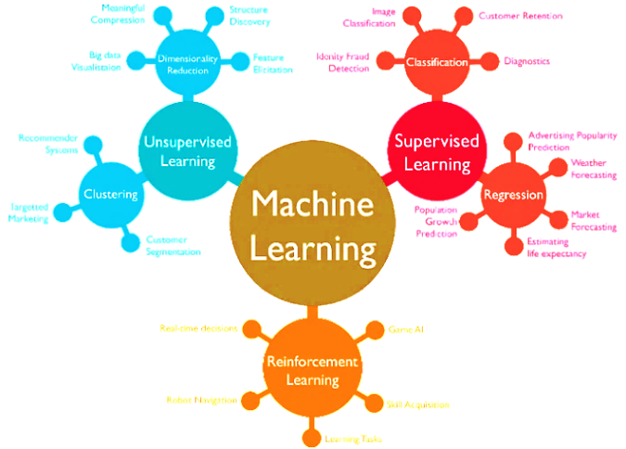

Fig 1.2 Machine learning model **[2]**

All identification or authentication technologies operate using the following four stages:

1. Capture: A physical or behavioural sample is captured by the system during Enrolments and also, in identification or verification process.
2. Extraction: unique data is extracted from the sample and a template is created.
3. Comparison: the template is then compared with a new sample.
4. Match / non- match: the system decides if the features extracted from the new Samples are a match or a non-match.

In Facial recognition there are two types of comparisons: -

VERIFICATION- The system compares the given individual with who they say they are and gives a yes or no decision.

• IDENTIFICATION- The system compares the given individual to all the other individuals in the database and gives a ranked list of matches

## 1.4 Image Processing

### 1.4.1 Description

Image processing is a way to convert an image to a digital aspect and perform certain functions on it, in order to get an enhanced image or extract other useful information from it. It is a type of signal time when the input is an image, such as a video frame or image and output can be an image or features associated with that image. Usually, the [AWS Image Processing](https://www.mygreatlearning.com/academy/learn-for-free/courses/aws-image-processing?gl_blog_id=36358) system includes treating images as two equal symbols while using the set methods used.

It is one of the fastest growing technologies today, with its use in various business sectors. Graphic Design forms the core of the research space within the engineering and computer science industry as well**. [1]**

### 1.4.2 Steps Involved in Image processing

Image processing basically involves the following three steps.

1. Importing an image with an optical scanner or digital photography.
2. Analysis and image management including data compression and image enhancement and visual detection patterns such as satellite imagery.
3. It produces the final stage where the result can be changed to an image or report based on image analysis.

Image processing is a way by which an individual can enhance the quality of an image or gather alerting insights from an image and feed it to an algorithm to predict the later things.

### 1.4.3 Working of Machine Learning based Image Processing

Typically, machine learning algorithms have a specific pipeline or steps to learn from data. ML algorithms need a considerable amount of high-quality data to learn and predict highly accurate results. Hence, we'll have to make sure the images are well processed, annotated, and generic for ML image processing. This is where Computer Vision (CV) comes into the picture; it's a field concerning machines being able to understand the image data. Using CV, we can process, load, transform and manipulate images for building an ideal dataset for the machine learning algorithm.

### 1.4.4 Importance of Image Processing

This is one of the many reasons why image processing is so important in any computer vision application.

-> Image improvement for human perception.

Goal – to improve subjective image quality.

-> Image improvement for machine perception

Goal – to simplify the subsequent image analysis and recognition.

–> Image transformation for technical purposes

e.g., change of image resolutions and aspect ratio for display on mobile devices.

-> Pure entertainment (visual effects))

. Goal- to get the artistic impression from the cool visual effect.

# CHAPTER 2

# LITERATURE SURVEY

## Health Management Workforce for India in 2030

* Main Objective: To estimate the supply, need and requirement for health management professionals for India in the year 2030.
* The overall supply capacity of trained health management professionals was 3,463 for 2017. However, based upon a service target approach India requires 11,304 health management professionals in 2017. If India is to reach the normative standards of 2.97 health managers per 100,000 population, the country would need 39,774 health management professionals in 2017. This need would increase to approximately 44,936 health management professionals by the year 2030 to maintain the normative standard of 2.97 health managers per 100,000 population.
* The supply side will match the requirement of HMPs earliest by the year 2026 in a high seat occupancy scenario. Moreover, there is a need to improve the quality of the output in terms of an explicitly stated and standardized competency framework that is tailored to the Indian context.

## Research on Face Recognition Technology Based on PCA [1]

Algo used: PCA(Principal Component Analysis)

* This paper expounds the basic principle and process of face recognition, and puts forward face recognition method based on PCA.
* This method is used to recognize LFW (labelled faces in the wild) face data set, and the parameter adjuster named gridsearchcv is used to adjust the parameters to further improve the precision and recall of face recognition.
* The experimental results show that the face recognition technology based on PCA not only reduces the dimension of face data, but also increases the recognition accuracy, which is a feasible face recognition method.
* The process of face recognition is divided into four parts: image acquisition, face detection, feature extraction and face classification and recognition.

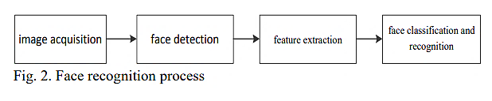

Fig 2.1 Flowchart of Face Recognition

## Attendance System Based on Face Recognition System Using CNN-PCA Method and Real-time Camera[2]

* Algo used: Convolutional Neural Network (CNN) – based PCA(principal Component Analysis)
* One of the implementations of the human face recognition system is used as an attendance system.
* The attendance system uses faces as objects to be detected and recognized as a person's identity and then stored as a face database. The process of matching face image data captured by the camera with face images that have been stored in the face database will result in face identification of the object faces captured by the camera.
* The face recognition-based attendance system in this study uses a hybrid feature extraction method using CNN-PCA (Convolutional Neural Network - Principal Component Analysis).
* The proposed method can produce a face recognition that has a high accuracy of up to 98%.

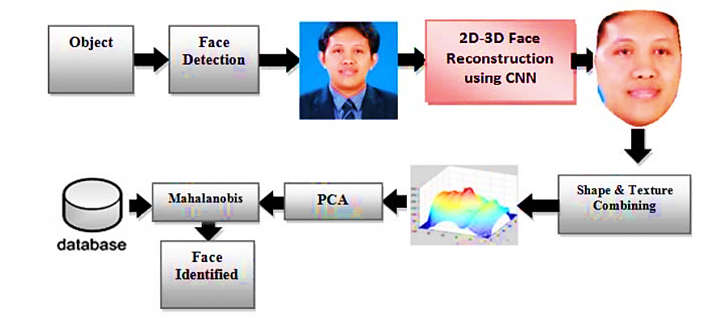

Fig 2.2 Process involved in facial recognition

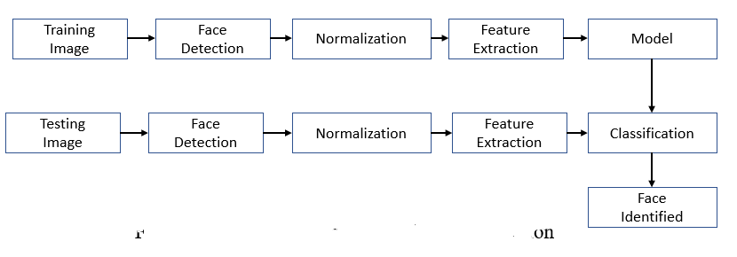

Fig 2.3 Stages of the process of facial recognition

## Face Recognition Rate Using Different Classifier Methods Based on PCA

* Algo used: Classifier Methods based on PCA(principal Component Analysis)
* This paper describes the different classifier methods with minimum means of clusters to achieve face recognition rate of humans from the feature extracted of training face image data for many sets of images as a data base.
* Principal Component Analysis (PCA) is a robust method used as feature extraction techniques for face recognition but the recognition decreases with the variation of person’s actions.
* Three classifier methods are used to obtain the distance of recognition.
* the Euclidian distance method,
* the Squared Euclidian Distance method,
* the city-Block Distance method
* The cluster method with Squared Euclidian Distance method produces higher a recognition rate 100% near the Euclidian Distance method which gives a human face recognition rate 98% higher than the city-Block Distance method which gives a recognition rate 95%.

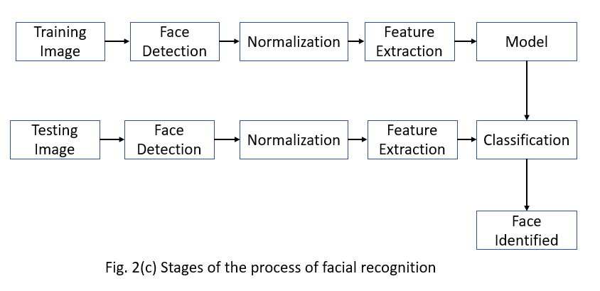

Fig 2.4 Stages of the process of facial recognition

**CHAPTER 3**

# METHODOLOGY

The Hospital Management Project will be built using the following :

* **Languages and Library :**

**PYTHON: The** entire project uses Python and its various libraries for implementation of various functionalities.Python is a high-level, interpreted, interactive and object-oriented scripting language. Python is designed to be highly readable. It uses English keywords frequently where as other languages use punctuation, and it has fewer syntactical constructions than other languages.

**OpenCV**: OpenCV is an open-source image recognition library. It is used for machine learning, computer vision and image processing. You can extract the most out of OpenCV when integrated with powerful libraries like NumPy and Pandas.

**PHP**: PHP is a server scripting language, and a powerful tool for making dynamic and interactive Web pages. PHP code is embedded in HTML code and is executed on the server, generating dynamic content that is served to the user's web browser. It is known for its ease of use, flexibility, and compatibility with various web servers and operating systems.

* **FRAMEWORK USED:**

**FLASK:** Flask is a web application framework written in Python. Flask is often referred to as a microframework. It is designed to keep the core of the application simple and scalable. Instead of an abstraction layer for database support, Flask supports extensions to add such capabilities to the application. Unlike the Django framework, Flask is very Pythonic. It is easy to get started with Flask because it doesn’t have a huge learning curve.

It is based on the Werkzeg WSGI toolkit and the Jinja2 template engine.

**Jinja2** : is a popular template engine for Python. A web template system combines a template with a specific data source to render a dynamic web page.

* **IMAGE CAPTURING AND DETECTION:**

**USING HAAR CASCADES** : Object Detection is done by working on various classifiers from the image detected .In this project we will be using Haar feature-based cascade classifiers which is an effective object detection method proposed by Paul Viola and Michael Jones .  It is a machine learning based approach where a cascade function is trained from a lot of positive and negative images. It is then used to detect objects in other images.

* **IMAGE RECOGNITION**

**PCA Algorithm** – The project will be implementing Face Recognition using a Face Recognition model using PCA (Principal Component Algorithm).

The main idea of using PCA for face recognition is to express the large 1-D vector of pixels constructed from 2-D facial image into the compact principal components of the feature space. This can be called eigenspace projection.

# CHAPTER 4

# TECHNICAL DESCRIPTION

## 4.1 PCA(Principal Component Analysis)

* Principal component analysis can be regarded as a neural network with only one layer.
* Its main idea is to reduce data redundancy. In the case of dimension reduction, it can also achieve the purpose of data processing.
* A small number of dimensions are used to represent the original data, which is convenient for better processing and storage of data, and convenient for data visualization.
* The process of dimensionality reduction is essentially a process of linear transformation. Its core idea is to project the data along the direction of maximum variance to retain the characteristics of the original data as much as possible.

## 4.2 ADVANTAGES OF PCA Over Another algorithm

* The principal components are orthogonal, and the data after dimensionality reduction have no influence on each other.
* The calculation method is simple, and the main operation is eigenvalue decomposition, which is easy to implement.

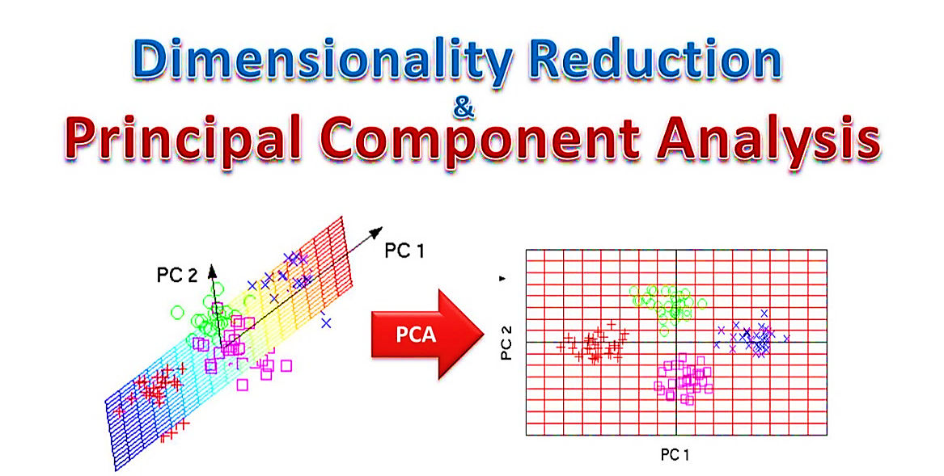

Fig 4.1 General Model of PCA

## 5.3 MATHEMATICAL ILLUSTRATION OF PCA

Assuming that for M samples with n features X={x1,x2… xm},the dimension should be reduced to dimension n , the main steps of applying principal component analysis are：

1. Centralize all samples, that is, subtract the respective average value from each feature.

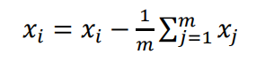

1. Calculate the covariance matrix of the sample, When the covariance is 0, it means that the two fields are completely irrelevant, which can maximize the information represented by the feature. In order to make the covariance 0, when we select the second basis, we can only select in the direction that the first basis is orthogonal, so as to achieve the purpose that the two direction vectors are orthogonal.

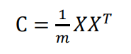

1. The eigenvalues and corresponding eigenvectors of the covariance matrix are calculated. The elements on the diagonal of the covariance matrix are the variances of the fields respectively, while the other elements are the covariance of the fields.
2. Sort the eigenvalues from large to small, select the largest K of them, and then take the corresponding K eigenvectors as row vectors to form the eigenvector matrix P.
3. According to the calculation of change matrix Y = PX, multiply the P matrix by the original data matrix X to obtain the k-dimensional data matrix Y after dimensionality reduction.

## 5.3 DATASET IMAGES

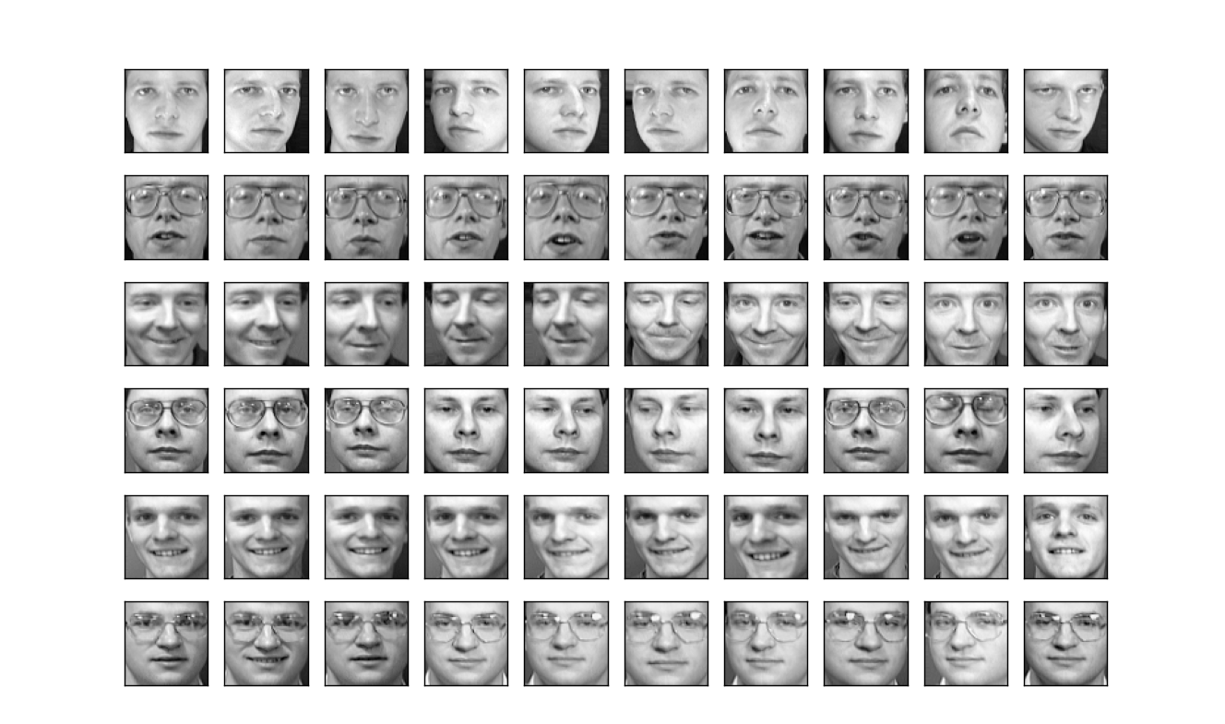

Fig. 4.2.1 Data from Olivetti dataset



Fig. 4.2.2 Labelling the Dataset

## 5.4 Proposed SYSTEM FLOWCHART

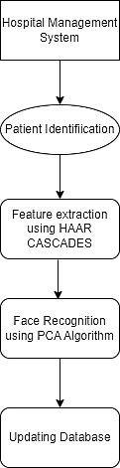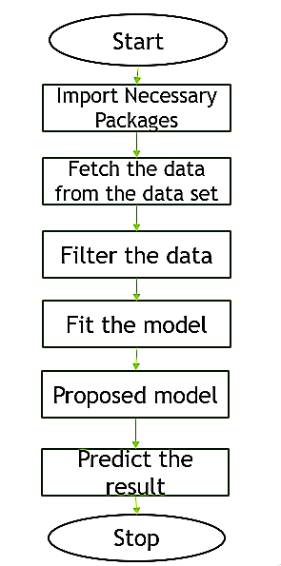

Fig. 4.3 Flowcharts of Proposed System

## 5.5 Model Training:

### 5.5.1.Olivetti Dataset



Fig. 4.4.1 Eigen faces forming the Eigen Vectors

### 5.5.2 ACCURACY GRAPH

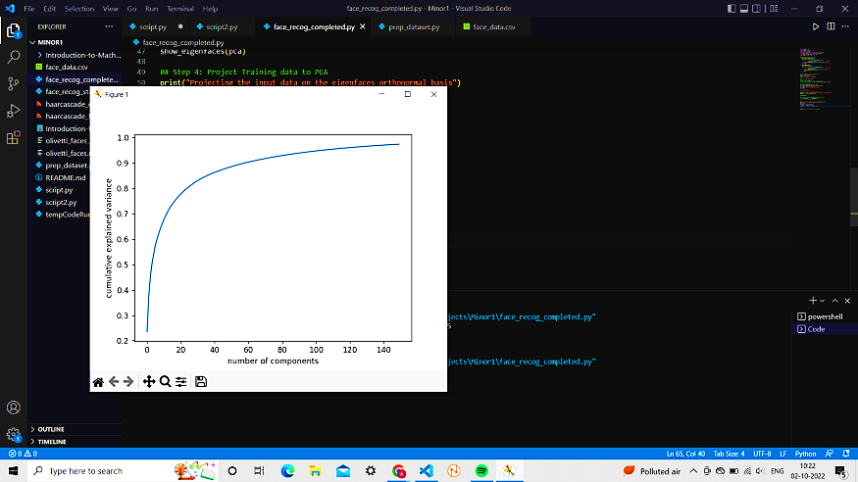

Fig. 4.4.2 Accuracy gained via proposed system:>97%

## 5.6 Testing:

### 5.6.1 Labels :

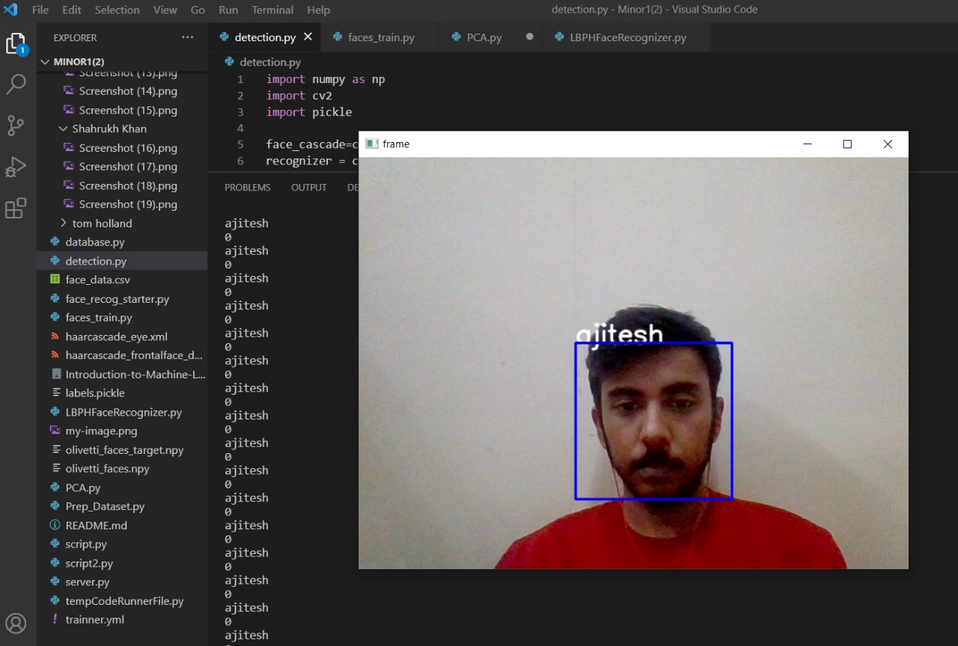

Fig 4.4.3 Labels

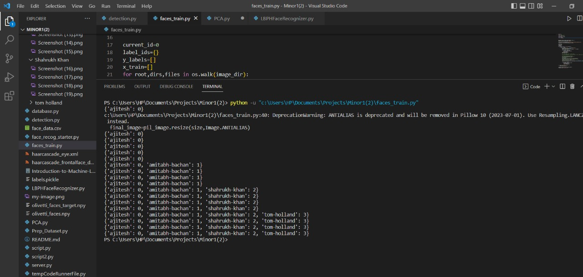

Fig 4.4.4 Labels with values

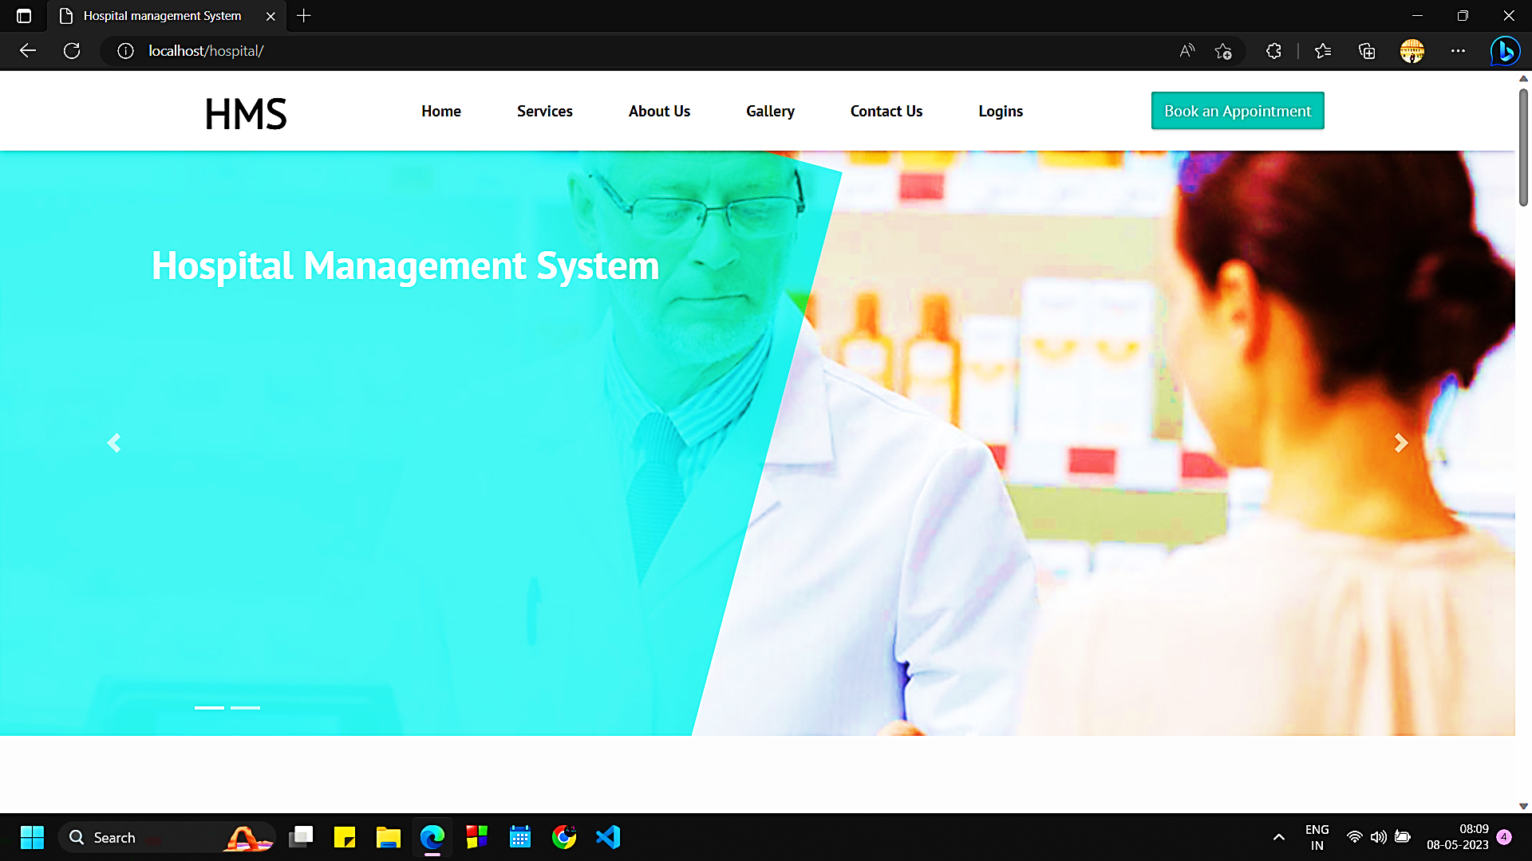

Fig.4.4.5 HMS Website

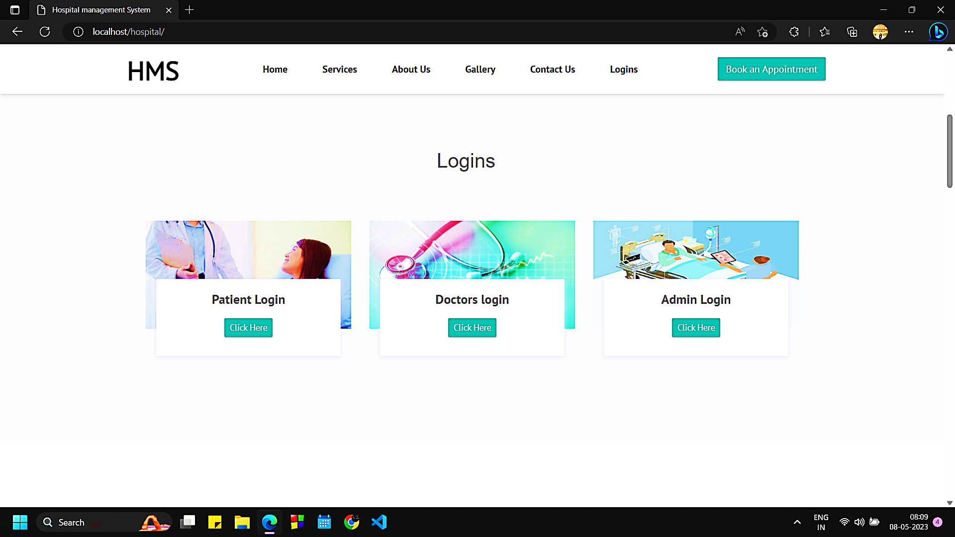

Fig. 4.4.6 Login Page

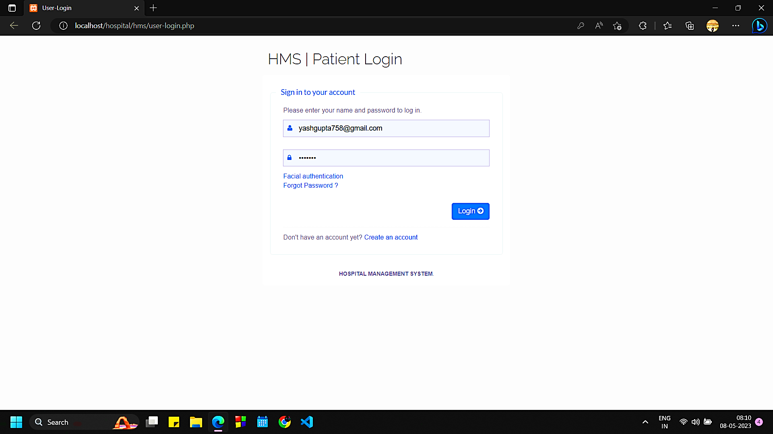

Fig 4.4.7 Patient Login

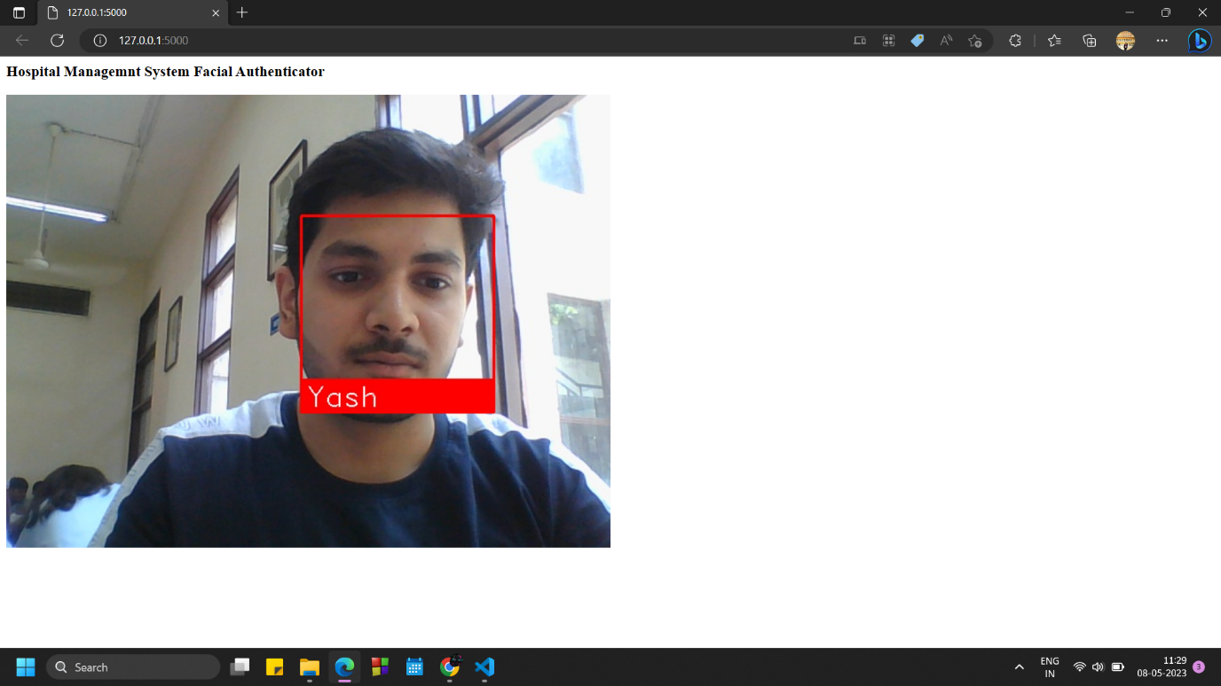

Fig 4.4.8 Face Recognition Window



Fig 4.4.9 Patient Dashboard

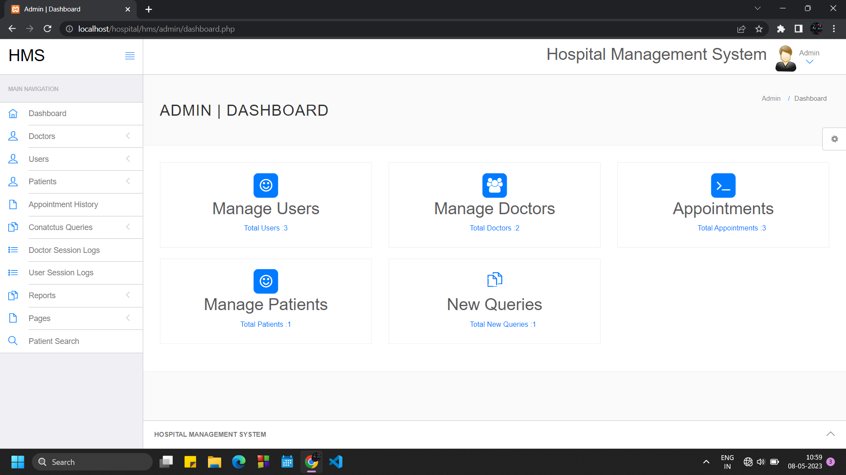

Fig 4.4.10 ADMIN LOGIN

# CHAPTER 5

# CONCLUSION AND FUTURE SCOPE

## 5.1 Conclusion

Since the hospital is enlarged and specialized, it is required to develop a system for efficiently managing while keeping the security and safety of large-scale high-density personnel such as visiting patients and employees with the strengthening of the Personal Information Protection Act, both patients and hospitals are experiencing inconveniences and the risk of medical accidents is increasing due to the restriction on the use of the existing social security number, which was used for pre-scheduling visits and medical treatments and examinations. Since hospitals are additionally deploying personnel to existing patient management systems or developing their own individual authentication systems, there is an urgent need to establish an efficient and unified personal authentication system.

## 5.2 Below are some benefits of biometric face recognition to include:

1. Better Security

A biometric facial recognition solution can help businesses identify [burglars](https://dictionary.cambridge.org/dictionary/english/burglar?q=burglars), [trespassers](https://dictionary.cambridge.org/dictionary/english/trespasser), and other criminals. Businesses can use it as a security tool to minimize [identity theft](https://en.wikipedia.org/wiki/Identity_theft).

1. Quicker Processing

It takes a facial recognition system second or less to recognize a face. In the era of [cyber-attacks](https://en.wikipedia.org/wiki/Cyberattack) and hacking, the businesses need this type of rapid technology to keep their systems secure.

1. Seamless Integration

Most facial recognition solutions are compatible with the existing [software](https://en.wikipedia.org/wiki/Software), which means companies won’t need to spend additional money on integration.

## 5.3 Goals of our system:

1. The system should be easy to operate.
2. The working on the model will be well planned and organised.
3. The level of accuracy in the proposed system will be high due to proper storage of information.
4. Provide quick and efficient retrieval of information via our website.
5. The reliability of the model will be high.
6. Cost Effectivity

# 

# REFERENCES

1. Y. Wang and Q. Wu, "Research on Face Recognition Technology Based on PCA and SVM," 2022 7th International Conference on Big Data Analytics (ICBDA), 2022, pp. 248-252, doi: 10.1109/ICBDA55095.2022.9760320.
2. E. Winarno, I. Husni Al Amin, H. Februariyanti, P. W. Adi, W. Hadikurniawati and M. T. Anwar, "Attendance System Based on Face Recognition System Using CNN-PCA Method and Real-time Camera," 2019 International Seminar on Research of Information Technology and Intelligent Systems (ISRITI), 2019, pp. 301-304, doi: 10.1109/ISRITI48646.2019.9034596.A
3. E. I. Abbas, M. E. Safi and K. S. Rijab, "Face recognition rate using different classifier methods based on PCA," 2017 International Conference on Current Research in Computer Science and Information Technology (ICCIT), 2017, pp. 37-40, doi: 10.1109/CRCSIT.2017.7965559.
4. E. I. Abbas “Effect of Eigen faces Level on The Face Recognition Rate Using Principal Component Analysis”, Eng. & Tech, Journal, Vol. 33, No. 3, 2015.

# APPENDICES

### Appendix A: Technical Terms

• **OS** - Python OS module provides the facility to establish the interaction between the user and the operating system. It offers many useful OS functions that are used to perform OS-based tasks and get related information about operating system. The OS comes under Python's standard utility modules.

• **CV2** - OpenCV (Open-Source Computer Vision Library) is an open-source computer vision and machine learning software library. OpenCV was built to provide a common infrastructure for computer vision applications and to accelerate the use of machine perception in the commercial products.

• **NumPy** - NumPy is a library used for working with arrays.

• **Pandas** - Pandas are an important library for data scientists. It is an open-source machine learning library that provides flexible high-level data structures and a variety of analysis tools. It eases data analysis, data manipulation, and cleaning of data. Pandas support operations like Sorting, Re-indexing, Iteration, Concatenation, Conversion of data, Visualizations, Aggregations, etc.

• **PIL** - This library provides extensive file format support, an efficient internal representation, and fairly powerful image processing capabilities.

• **PICKLE** - The pickle module implements binary protocols for serializing and de-serializing a Python object structure.

• **MATPLOTLIB.PYPLOT** –This library is responsible for plotting numerical data. And that’s why it is used in data analysis. It is also an open-source library and plots high-defined figures like pie charts, histograms, scatterplots, graphs, etc.

• **SKLEARN**-The sklearn library contains a lot of efficient tools for machine learning and statistical modelling including classification, regression, clustering and dimensionality reduction

Important functions used:

• .imshow()- function use to show image as an output

• .read_csv()-function used to read a dataset or images